CS560 Knowledge Discovery and Management
Final Project Submission
Social Trend Analysis




Team:
Aditya Deshpande,
Tej Kiran Meka,
Mahesh Vemula,
Ashok Rudraraju.

- Project deployment: https://github.com/tmrhc/KDM-PROJECT/tree/master/Final%2 0Project%20Folder
- Project Video: http://www.youtube.com/watch?v=ZVVpgND0Wvs
User Manual
Table of Contents

pg no.
a) Introduction .......................................................................................... 2
b) Motivation ........................................................................................... 2
c) How to use System ..................................................................................... 2
d) Error Recognition and Handling ............................................................. 2
e) Interaction with the system ....................................................................... 2
f) Bugs and Deficiencies ................................................................................. 8

a) Introduction:
Social Trend Analysis is a project done to fulfill the requirements of the course Knowledge Discovery Management course for spring 2014. This website helps the users to know about the popular Operating Systems around the world.
b) Motivation:
Operating Systems are most important factor for the devices that people carry every day. It is an important factor to choose the right operating system for his/her device that produces better through put and operates with lower response time. User generally be in a state of confusion while purchasing devices with better operating systems. Our goal is to help user to know the popular operating system in that area that helps the user to know about it and this enables user to purchase or follow the trends of operating systems in his/her geographical location. As the social network is more popular these days for expressing the user comments or reviews about a product. We thought to collect data from social media and run the data analytics and extract the data required that represents the popular operating systems across the globe.
c) How to use the system?
The website we designed is user friendly and can easily understandable by the user. We designed our website using twitter bootstrap framework that enables user to access the website through any of this device such as Mobile, Laptop, Personal computer etc. We used HTML5, CSS3 and java script to represent results through our website. This website contains three main webpages Homepage, Analysis using Maps and Analysis using charts. User can easily navigate through any one of this pages. In Analysis using Maps page we represented the output that we obtained after running data analytics on the twitter stream data through Map view. In Analysis using charts page we represented the output through charts view. User can navigate through these pages to evaluate and know about the popular operating systems.
d) Error Recognition and Handling:
In this website user may get error while accessing data through Analysis using Maps and Analysis using Charts pages. The main reason behind this is when the solr is down in the server. When the solr is down then json data can't be retrieved from solr and thus it doesn't reflects any data on the website. The only scenario user can do is to wait for solr to be up. We can restart the solr in order to set the solr to make it start working.
e) Interaction with System:
As mentioned before the following screenshot represents the home page of our website.
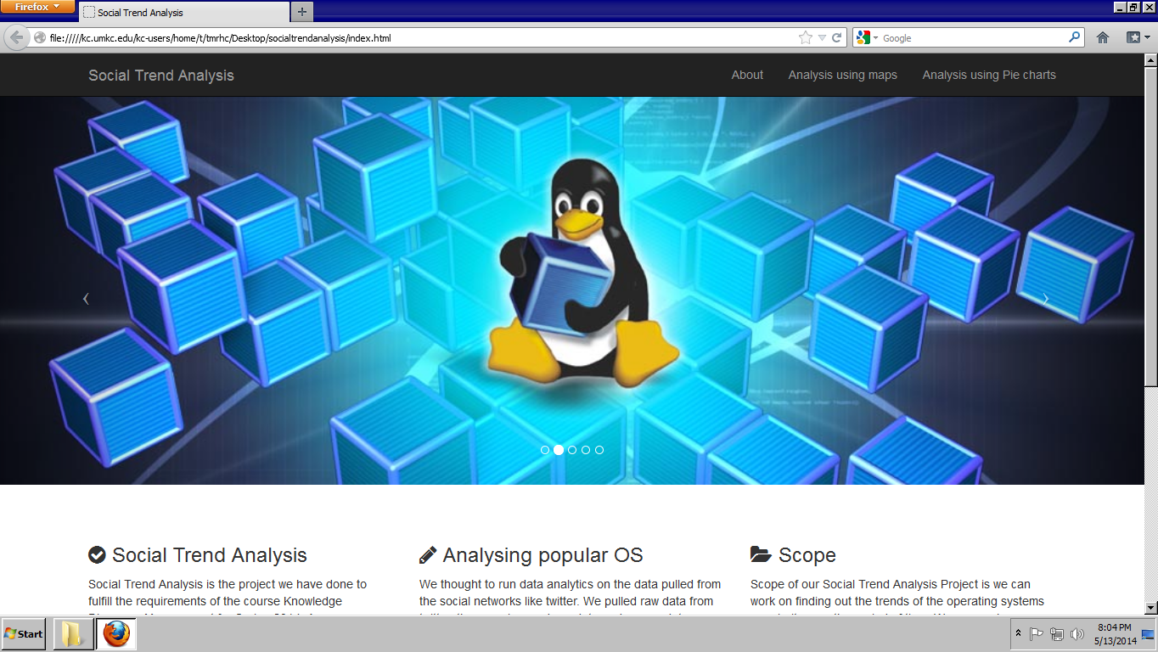

- User can click on Analysis using Maps button available on the navigation bar of the website.
- When it is clicked Analysis using Maps page will be accessed by the user. Below Screenshot represents the page that will be available for the user.

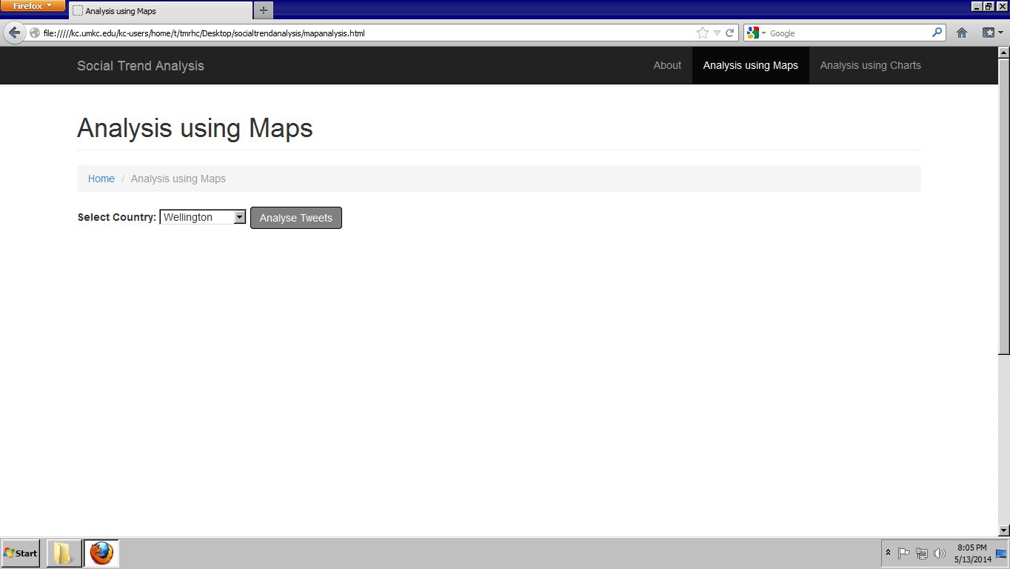
- User then selects the place and clicks on Analyze Tweets button.

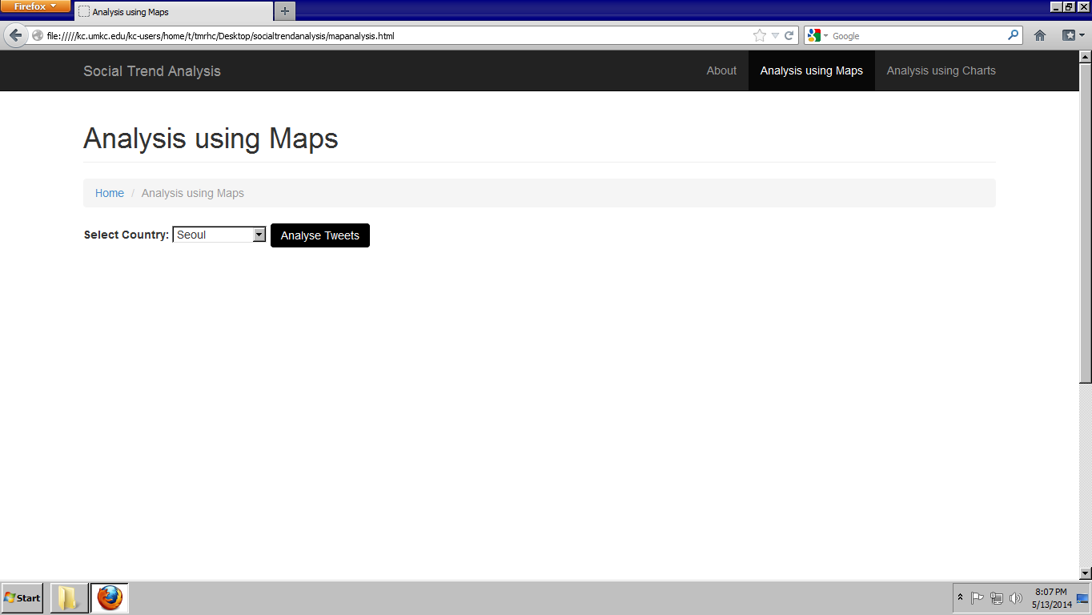

- User selects the place and clicks on the button Analyze tweets.

- Map is displayed on the webpage with the marker pointed on the location selected by the user.

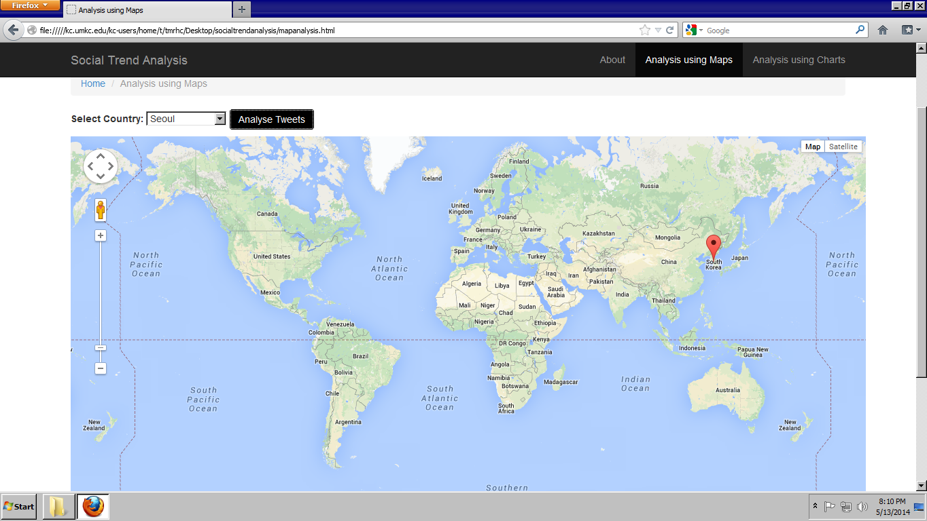

- When user clicks on pointer then the popularity of operating systems will be displayed on the marker.

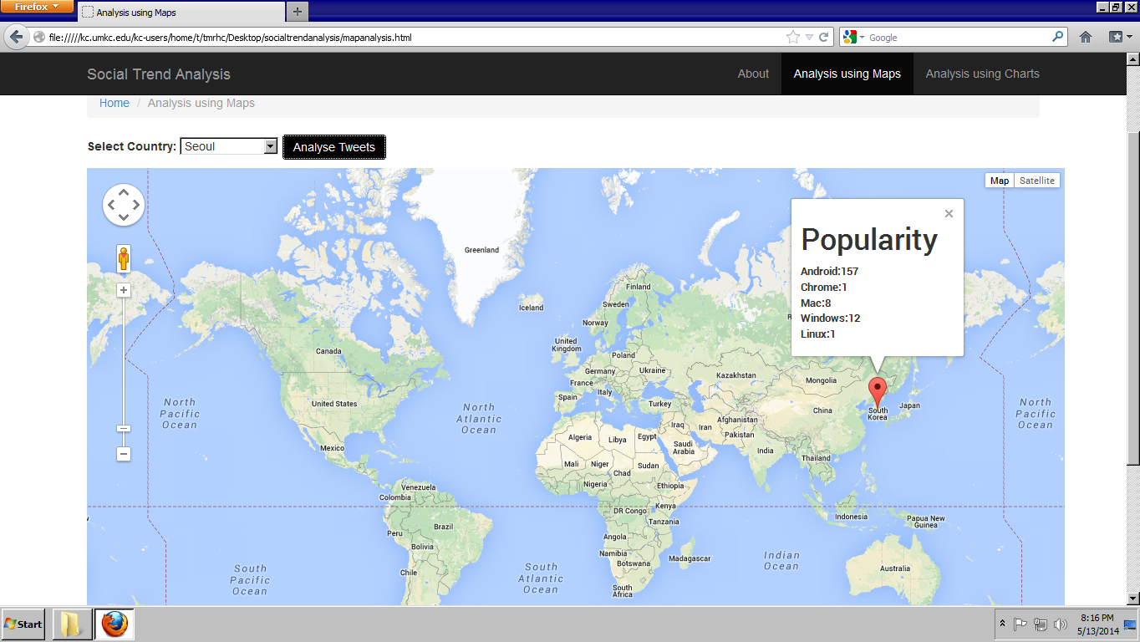
- Here user can expect error while retrieving the data. Solr in cloudera may be down and it might not retrieve data from solr. He has to wait for a while so that he can retrieve data when the solr will be up.

- User can navigate through the analysis using charts button provided in the website.

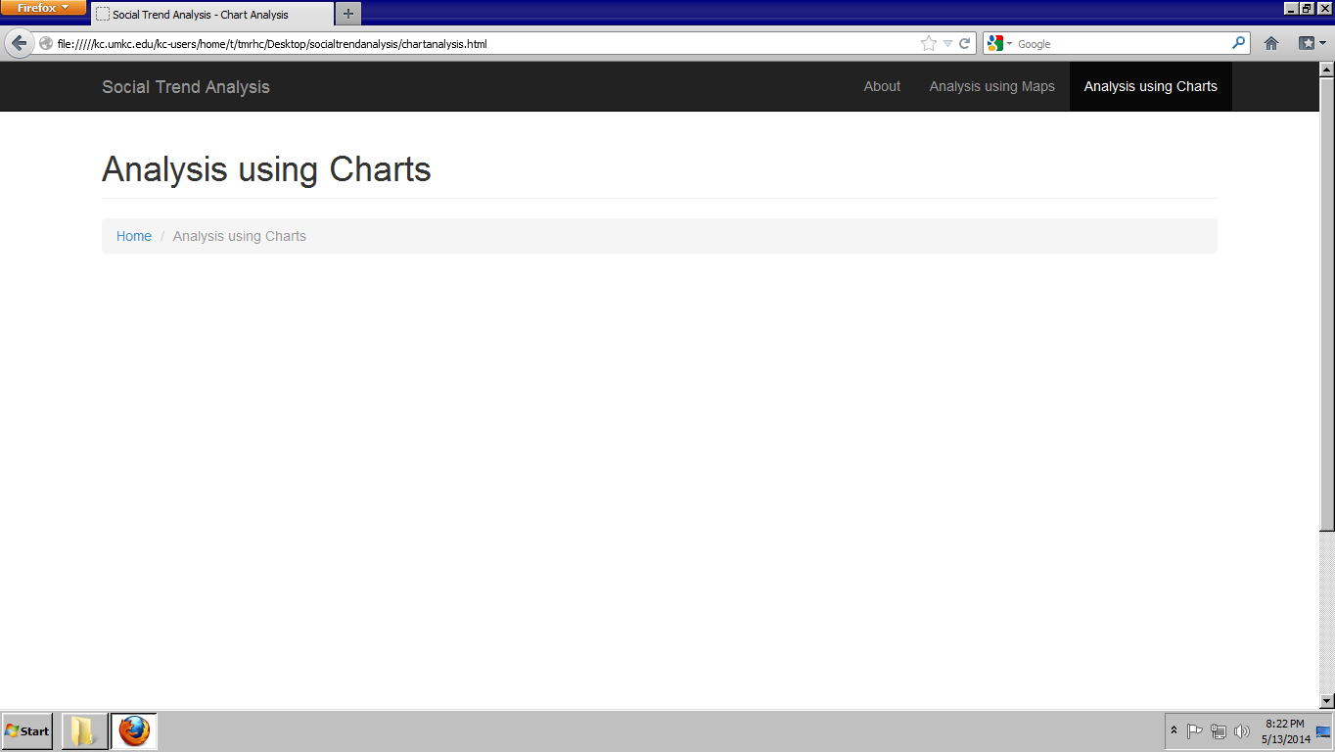

- User can select a place given in the drop down list and clicks on the button Analyze tweets button.

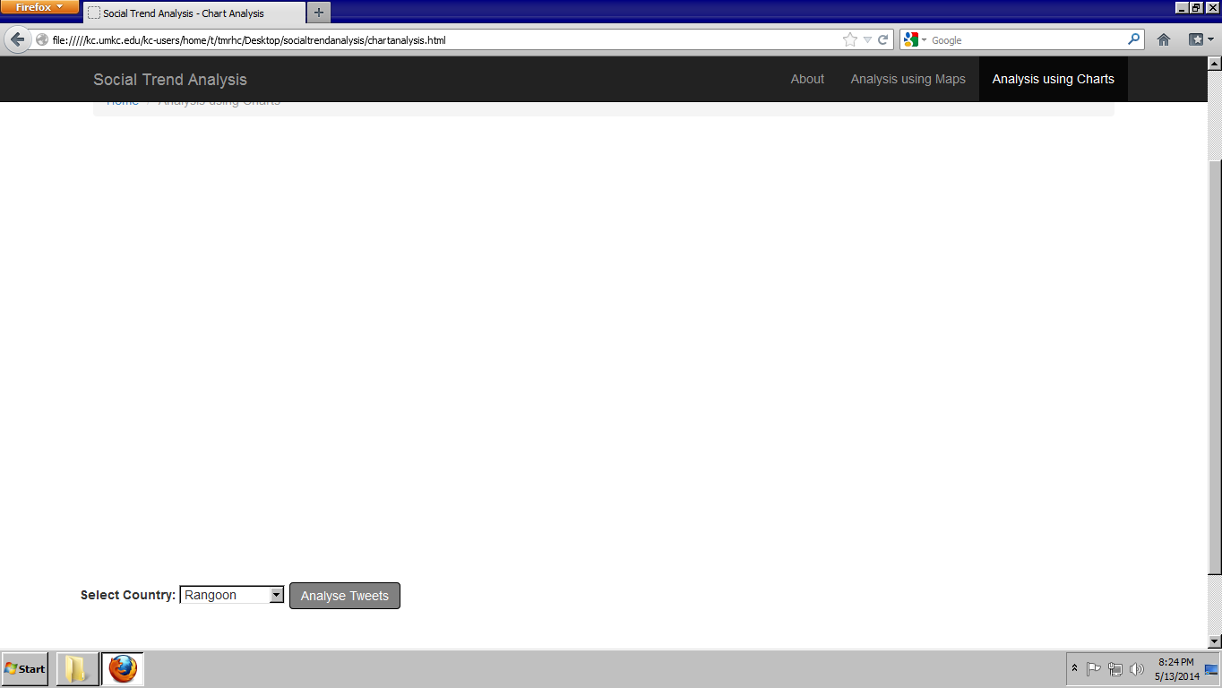

- Chart will be displayed on webpage with the popularity of operating systems.

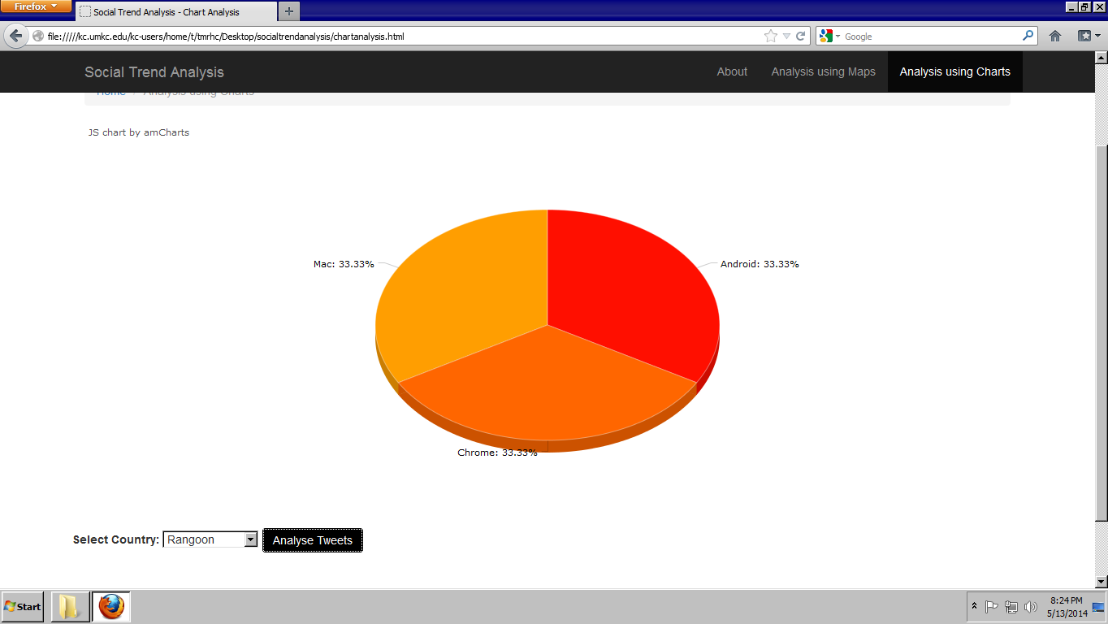
Here user can expect the same error when the solr is down.

f) Bugs and Deficiencies:
When the analyze tweets button is clicked aggressively user may get the "error" message displayed on the webpage in Analyze using maps feature.
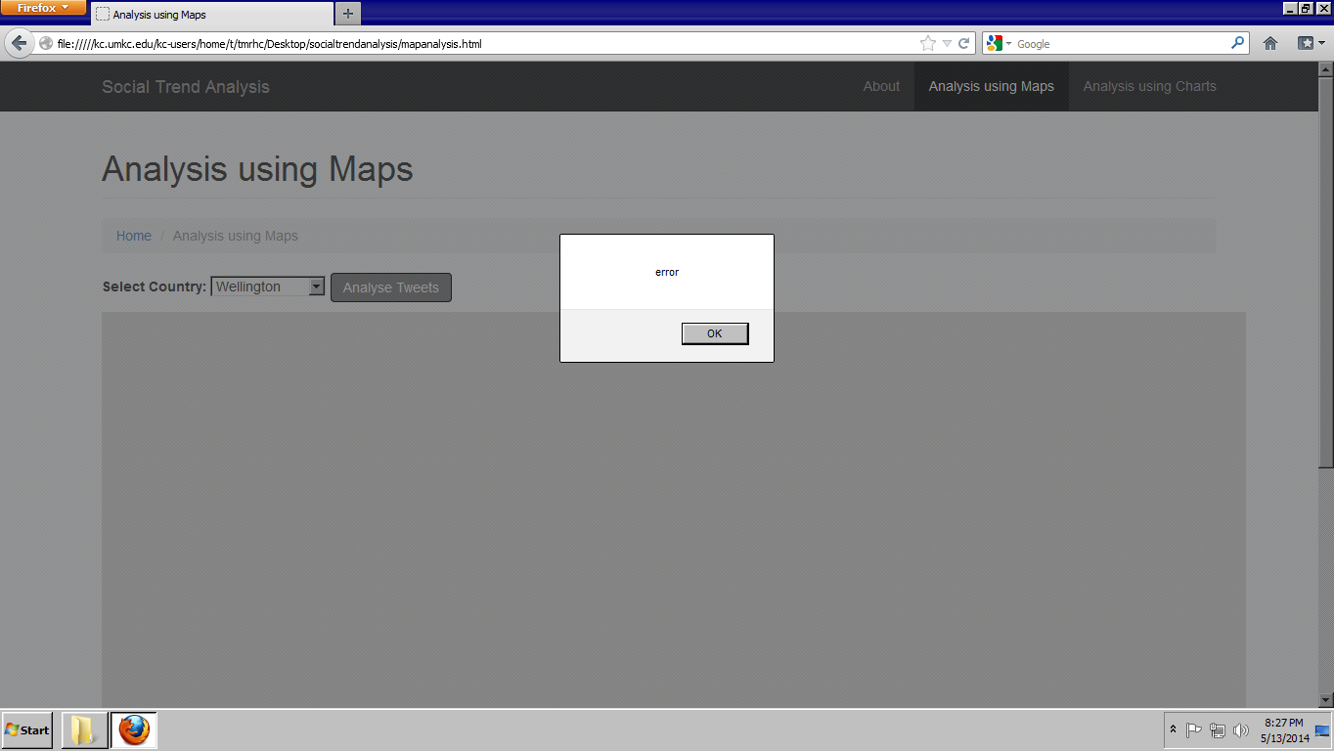

Project Management
- Final project evaluation: We have done our best to implement all the functionalities mentioned in our project plan. But unfortunately we did not implement to predict popularity of technologies through our site due to lack of time. We have implemented SOA architecture in our project. We are satisfied with both our database design and presentation layer (UI design).Agile process model helped us to track the status of project like where we are after each increment and what approach could be followed in next increment for better delivery. If the requirements had changed say after second increment, it could have been much challenging. We adhered to our project plan schedule and submitted reports on time. We have divided tasks based on increment basis rather than dividing each task involving in each and every member. For example, if one does documentation for this increment then that person would do coding in next increment. It does resemble our planned structure because at end of the project each member is good at every task. Initially we have faced few problems, but later each member is able to cope up with other. If it would have been a real time project then we would had our project plan crystal clear in our minds before starting the project. We would have analyzed the features mentioned in plan would be completed within stipulated time or not. We would have maintained mitigation plan if something goes wrong. We would strongly recommend to focus more on plan preparation and analyze the features mentioned in plan could be completed within time or not.

